- Create one IAM user and assign EC2 and S3 full access roles.
Login to AWS Console.
- Search IAM.
- Open IAM.
- Left side menu → click Users.
- Click Create user.
- Enter user name, for example:
ec2-s3-admin-user
- Select Provide user access to the AWS Management Console only if you want this user to login to AWS Console.
- Click Next.
- Select Attach policies directly.
- Search and select:
AmazonEC2FullAccess
AmazonS3FullAccess
- Click Next.
- Review everything.
- Click Create user.

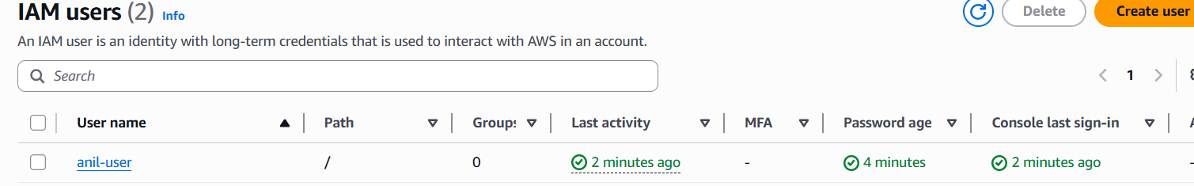
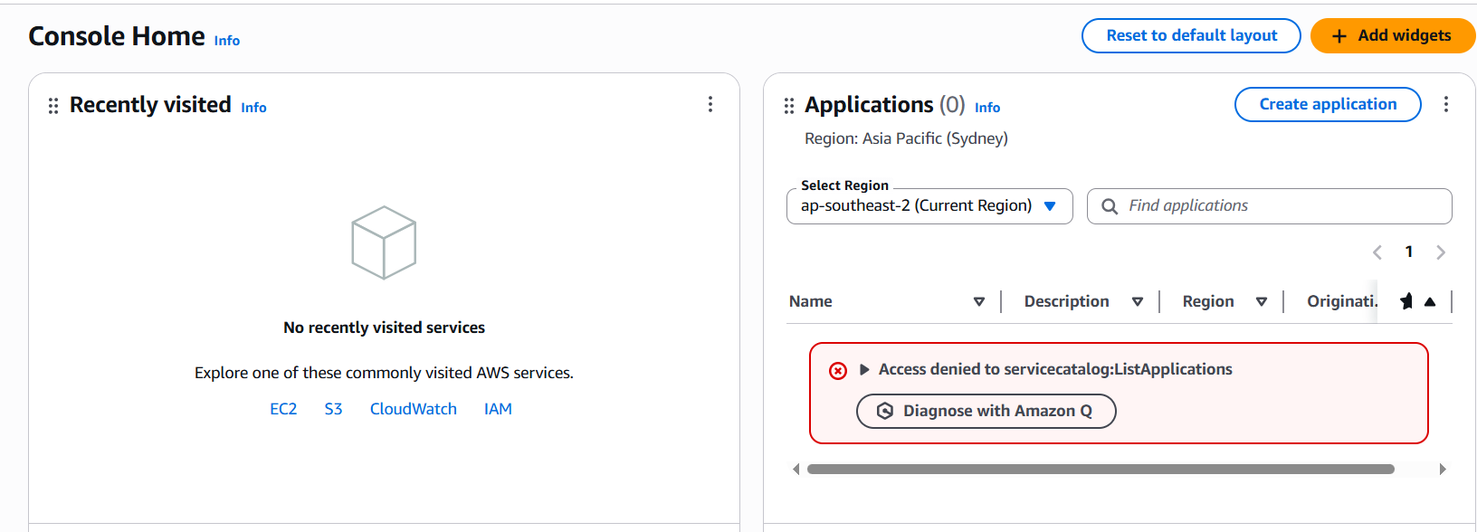
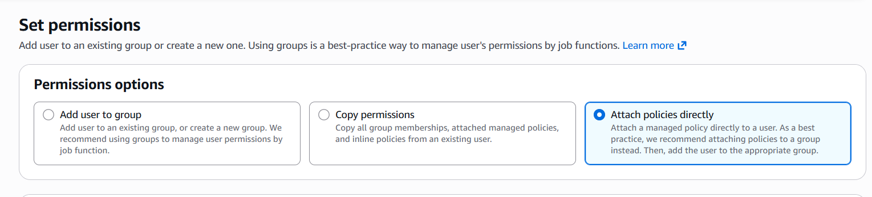
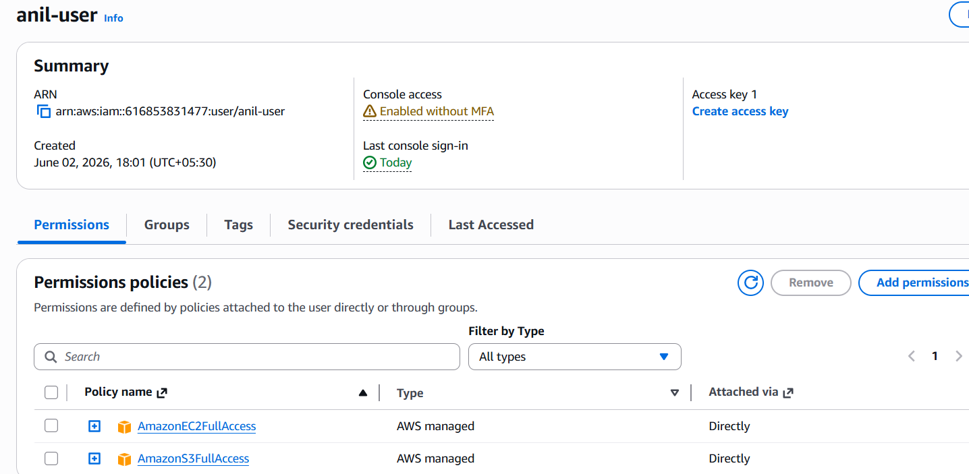

2. Create one group in IAM and assign read access for EC2.
Purpose: AWS allows you to create IAM user groups and attach policies to the group, so all users inside that group get those permissions
- Go to IAM.
- Left side menu → click User groups.
- Click Create group.
- Group name:
EC2ReadOnlyGroup
- In permissions, search:
AmazonEC2ReadOnlyAccess
- Select that policy.
- Click Create group.
Now the group has EC2 read-only permission.

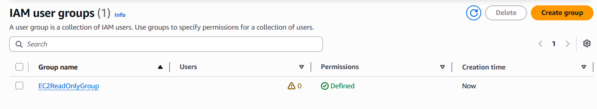
3. Create a new user named "Devops" and add to the group created in task 2.

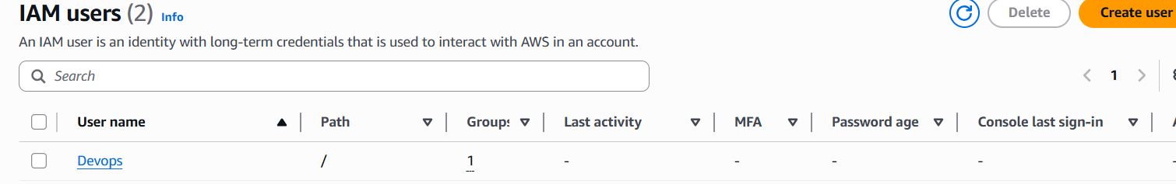

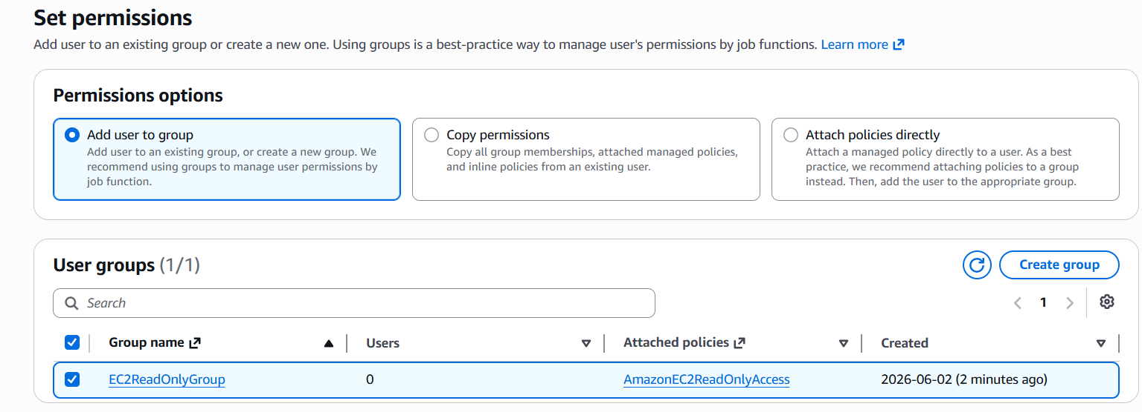
4. Write a bash script to create an IAM user with VPC full access.

- Login to AWS Console using root account or an admin user.
- Search IAM in the AWS search bar.
- Open IAM.
- Click Users.
- Open your current user:
anil-user
- Go to Permissions tab.
- Click Add permissions.
- Select Attach policies directly.
- Search for this policy:
IAMFullAccess
- Select IAMFullAccess.
- Click Next.
- Click Add permissions.
- Now go back to your Git Bash.
- Check your AWS identity:
aws sts get-caller-identity
- If it shows your account details, continue.
- Create the script file:
vi create_vpc_user.sh
- Press i to insert mode.
- Paste this script:
- Give execute permission:
chmod +x create_vpc_user.sh
- Run the script:
./create_vpc_user.sh
- Verify IAM user was created:
aws iam get-user --user-name Devops-VPC
- Verify VPC full access policy was attached:
aws iam list-attached-user-policies --user-name Devops-VPC
- You should see this policy in the output:
AmazonVPCFullAccess

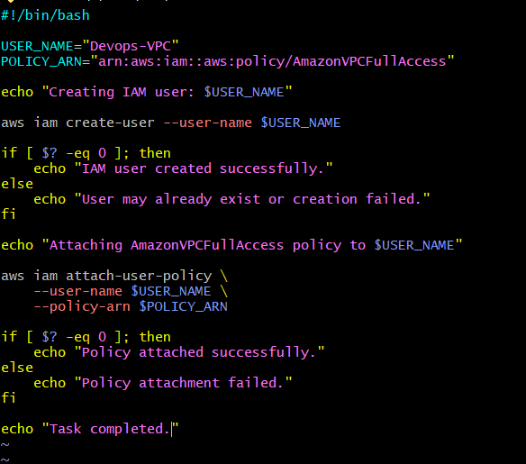
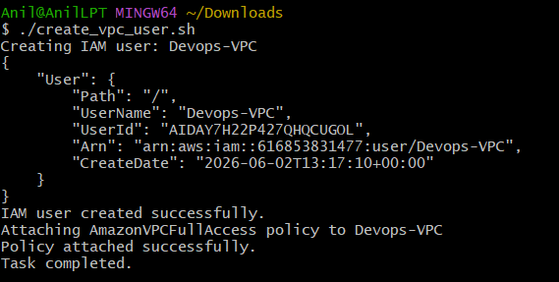
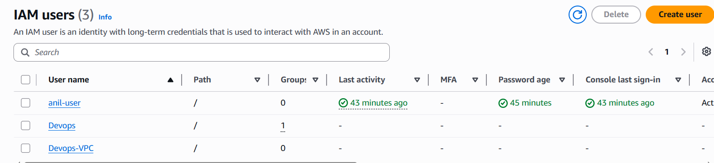
5. Create an IAM policy to allow EC2 access for a specific user in specific regions only.
You will create a custom IAM policy that allows a user to use EC2 only in one region.

- Login to AWS Console.
- Login using the IAM user where you attached this policy:
EC2-Region-Limited-Access
- On the top-right side, click the Region dropdown.
- Select the allowed region:
Europe (Stockholm) eu-north-1
- In the AWS search bar, search:
EC2
- Open EC2.
- Click Instances from the left side.
- Click Launch instances.
- In Name and tags, enter:
region-test-allowed
- In Application and OS Images, select:
Amazon Linux 2023 AMI
- In Instance type, select:
t3.micro
or if t3.micro is not available, select:
t2.micro
- In Key pair, click Create new key pair.
- Enter key pair name:
region-test-key
- Select key pair type:
RSA
- Select private key format:
.pem
- Click Create key pair.
- The key file will download automatically.
- In Network settings, keep default VPC.
- Keep subnet as default or no preference.
- Keep Auto-assign public IP as enabled.
- In security group, select Create security group.
- Allow SSH from your IP only if asked.
- In Configure storage, keep default:
8 GiB
- Click Launch instance.
- If the policy is correct, the instance should launch successfully in:
eu-north-1
- Take screenshot of the successful launch page.
- Now click the Region dropdown again.
- Select blocked region:
Asia Pacific (Mumbai) ap-south-1
- Search and open EC2 again.
- Click Instances.
- Click Launch instances.
- In Name and tags, enter:
region-test-blocked
- Select:
Amazon Linux 2023 AMI
- Select instance type:
t2.micro
or
t3.micro
- Keep key pair and network settings default.
- Click Launch instance.
- This time it should fail.
- You should see an error like:
You are not authorized to perform this operation
or
AccessDenied
- Take screenshot of the error.
- Now go back to the allowed region:
Europe (Stockholm) eu-north-1
- Open EC2 → Instances.
- Select the instance:
region-test-allowed
- Click Instance state.
- Click Terminate instance.
- Click Terminate to confirm.
- Take screenshot after termination

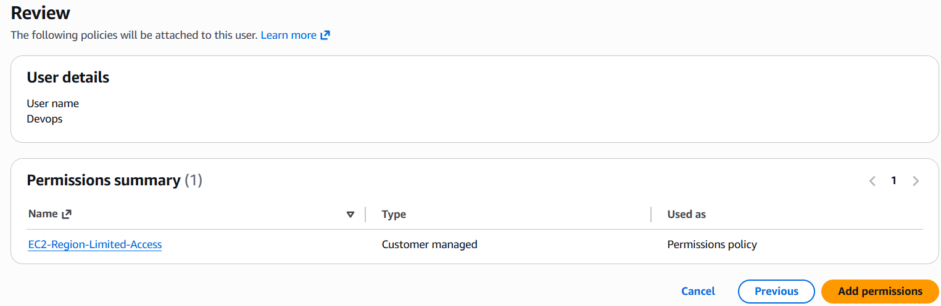
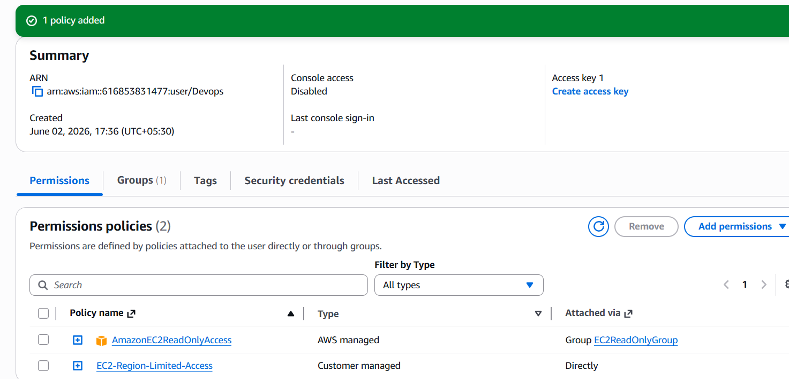
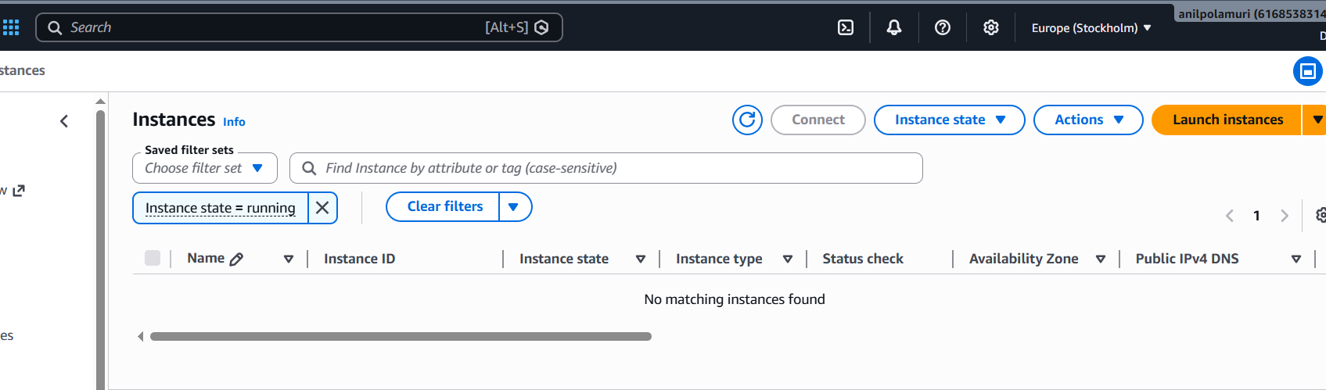

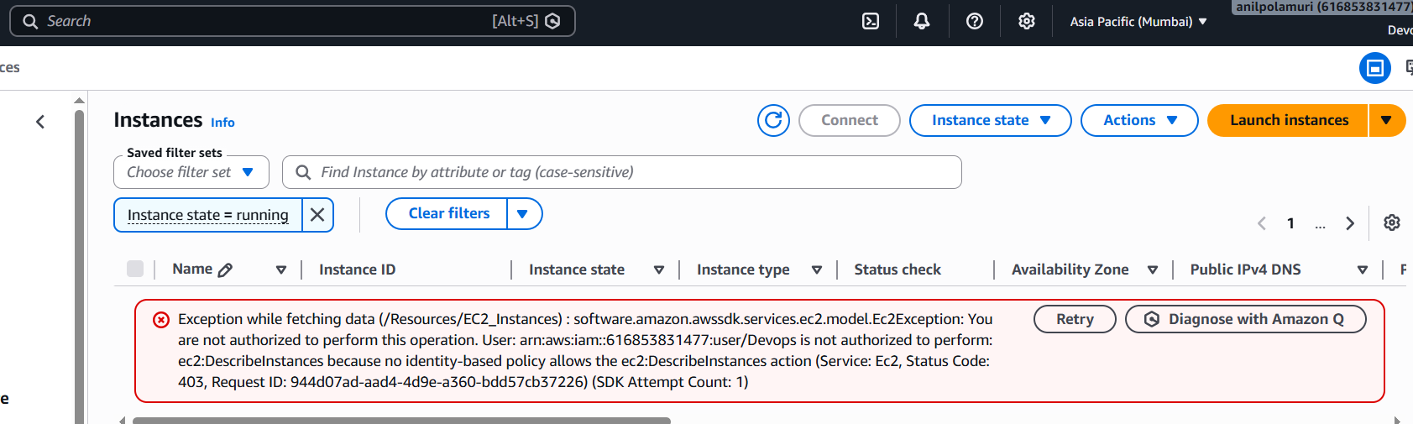

- We have two accounts: Account A and Account B. Account A user should access an S3 bucket in Account B

• Login to your AWS account.
• Search for IAM.
• Open IAM.
• Click Policies.
• Click Create policy.
• Select JSON tab.
• Remove the default JSON.
• Paste this policy
• Login to your AWS account.
• Search for IAM.
• Open IAM.
• Click Policies.
• Click Create policy.
• Select JSON tab.
• Remove the default JSON.
• Paste this policy
{
"Version": "2012-10-17",
"Statement": [
{
"Sid": "AllowS3CrossAccountAccess",
"Effect": "Allow",
"Action": [
"s3:GetObject",
"s3:ListBucket"
],
"Resource": [
"arn:aws:s3:::iam-full-access-bucket",
"arn:aws:s3:::iam-full-access-bucket/*"
]
}
]
}

Step 2: Attach policy to Account A user

Purpose
Creating a policy alone is not enough. We must attach it to your user so your user gets that permission.

Steps
- Go to IAM.
- Click Users.
- Open your IAM user:
anil-user
- Go to Permissions tab.
- Click Add permissions.
- Select Attach policies directly.
- Search:
My-cross-account-policy
- Select the policy.
- Click Next.
- Click Add permissions.
Now your user has permission to list and download objects from your friend’s bucket.

Step 3: Add bucket policy in Account B

Purpose
Even if Account A user has permission, Account B bucket must also trust/allow that user. This bucket policy gives permission from the bucket owner side.

Steps your friend should do
- Your friend should login to Account B.
- Go to S3.
- Open bucket:
iam-full-access-bucket
- Go to Permissions tab.
- Scroll to Bucket policy.
- Click Edit.
- Paste this policy:

Step 4: Test your AWS CLI identity

Purpose
This confirms you are using the correct Account A user before testing S3 access.

Command
aws sts get-caller-identity

Expected output
It should show:
Account: 616853831477
Arn: arn:aws:iam::616853831477:user/anil-user

Step 5: List files from friend’s bucket

Purpose
This checks whether your user can view the objects inside Account B bucket.

Command
aws s3 ls s3://iam-full-access-bucket

Your successful output
You already got this:
2026-06-02 17:59:10 17500685 introduction-devops.pptx
This means list access is working.

Step 6: Download the actual file

Purpose
This checks whether your user can read/download an object from Account B bucket.
You first tried:
aws s3 cp s3://iam-full-access-bucket/object.txt .
That failed because object.txt does not exist in the bucket.
The actual file name is:
introduction-devops.pptx

Account-A policy(json)
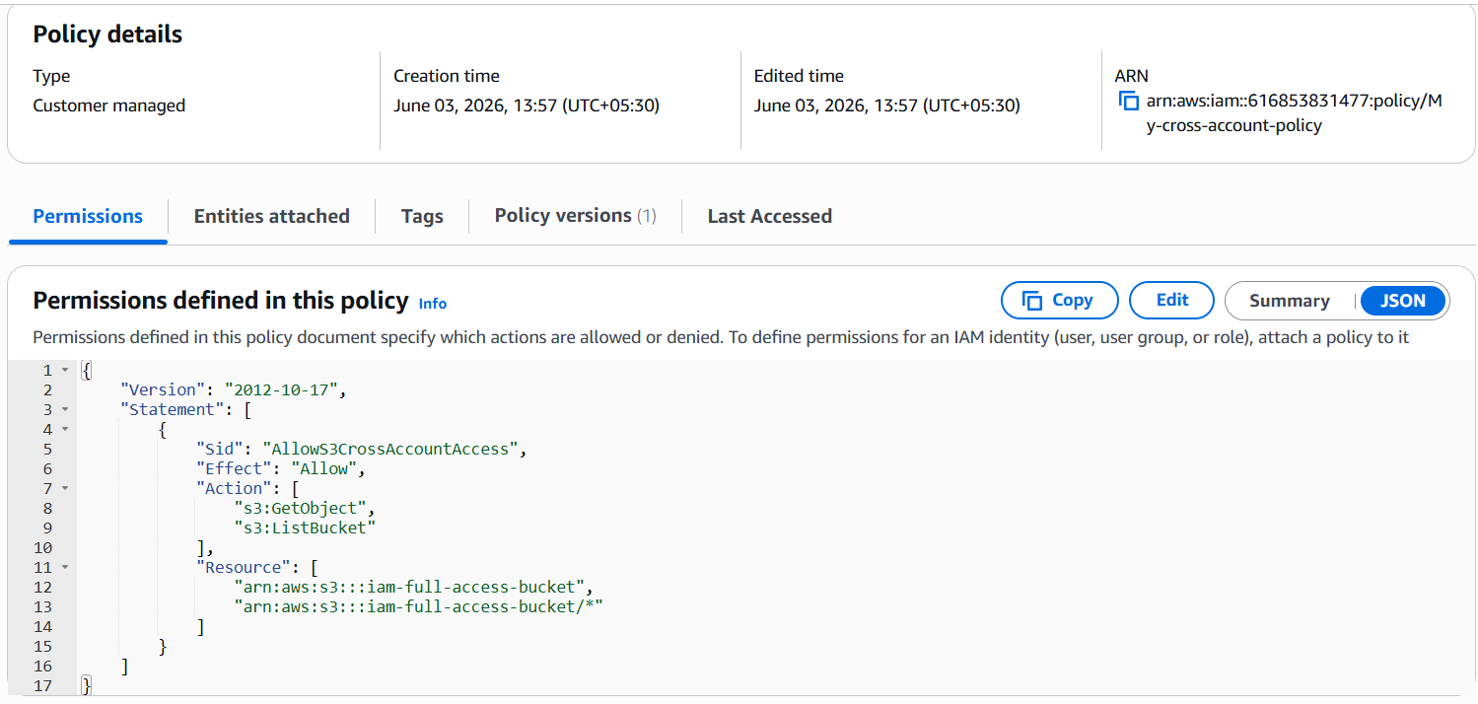
Policy Attached to user
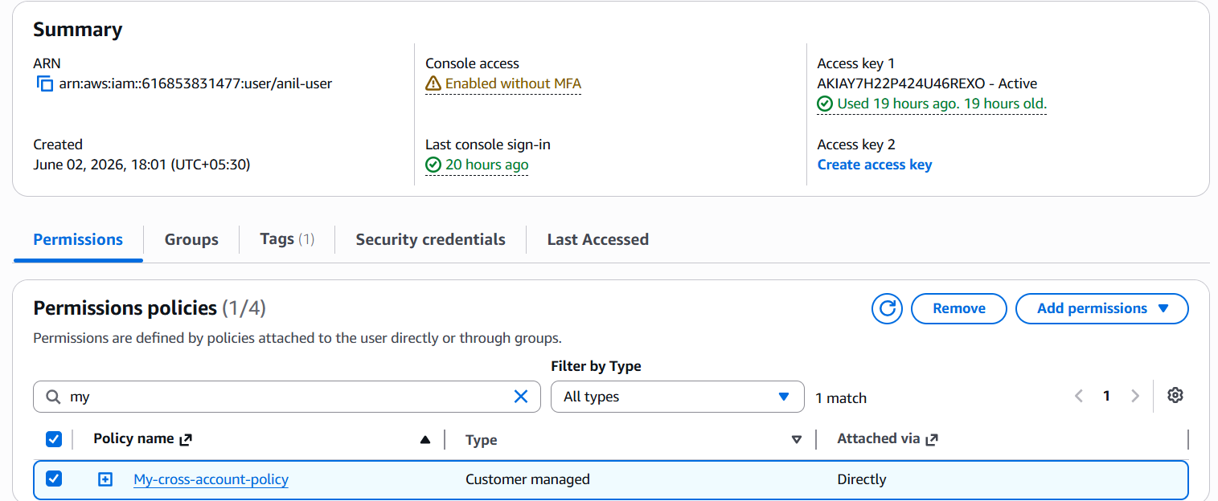
Account B bucket policy
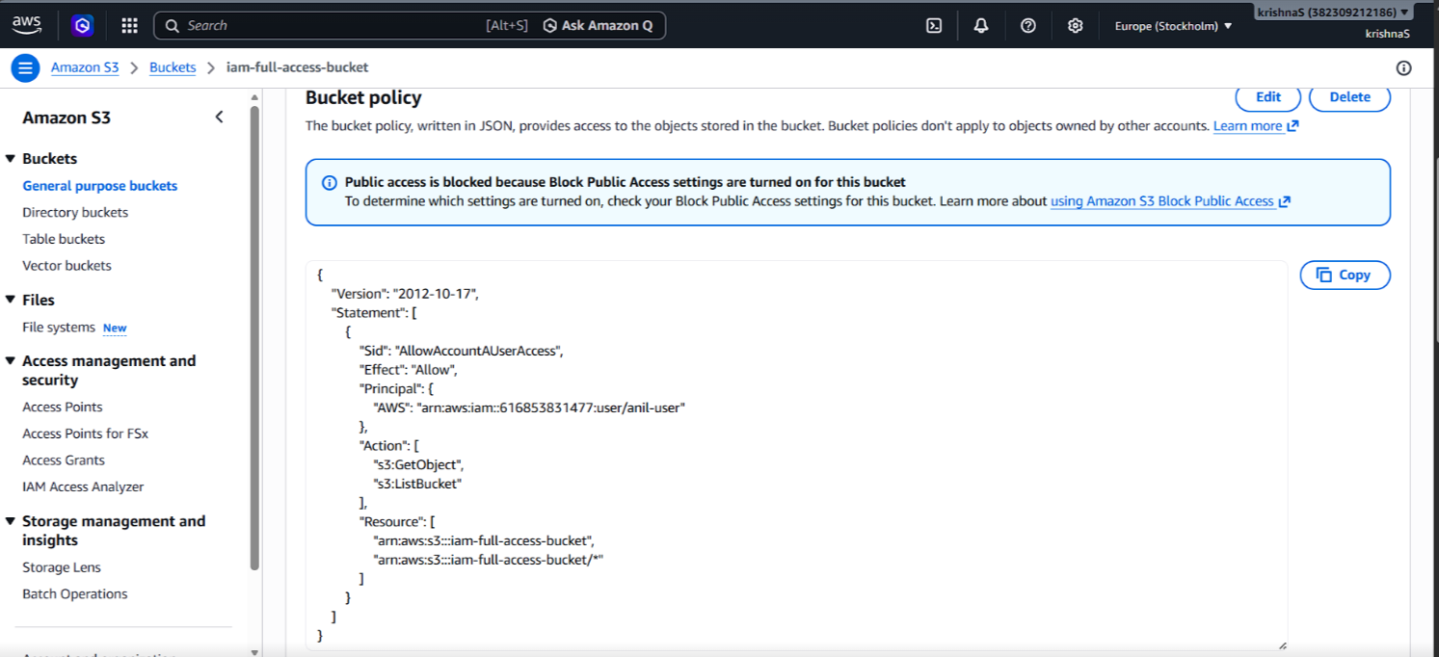
aws sts get-caller-identity output
5. aws s3 ls s3://iam-full-access-bucket output
6. aws s3 cp download output

